

**Vibe Coding: VS Code AI Dev Tool with Copilot**

**Helper Document**

Version No: 1.0

|  |  |  |  |
| --- | --- | --- | --- |
|  | **Prepared By / Last Updated By** | **Reviewed By** | **Approved By** |
| **Name** | AG | SB | JP |
| **Role** | Principal Architect | PM | Chief Architect |
| **Signature** | AG | SB | SB |
| **Date** | 15/7/2025 | 15/7/2025 | 15/7/2025 |

**Table of Contents**

1. Introduction 3

1.1 Purpose of this document 3

1.2 Scope 3

1.3 Out of Scope 3

1.4 Intended Audience 3

1.5 Acronyms 3

2. Setup & Get Started 4

2.1 Installation 4

2.2 IDE Setup 5

3. Plugins/Configuration 6

3.1 SQLite for Database Implementation 6

3.2 GitHub Copilot 7

4. Sample Prompts 11

5. References 12

5.1 Cognizant – VS Code vendor collaboration 12

6. Change Log 12

# Introduction

## Purpose of this document

This document provides comprehensive guidance on using the VS Code AI Dev tool for participation in the Vibe Coding Event at Cognizant.

## Scope

This document outlines the key steps for participants of the Vibe Coding event to register and configure the VS Code AI tool in preparation for the hackathon.

## Out of Scope

* AI components won't use Associate data for personalization or access PII.
* Troubleshooting of VS Code IDE, Azure & GitHub.

## Intended Audience

The intended audience of this document is

* Administration team for Vibe Coding Event
* Associates of Cognizant
* Architects, Designers and Developers involved in the Vibe Coding Event.

## Acronyms

|  |  |
| --- | --- |
| Acronym | Expansion |
| User | Cognizant Associates |
| News | News articles published on be.cognizant |
| Be.Cognizant | Content platform: <https://be.cognizant.com> |
| Hackathon | Vibe Coding Event |

# Setup & Get Started

## Installation

Install the VS Code App from the Company portal on your laptop. Access the installation guide here.

|  |  |
| --- | --- |
| **OS** | **Installation guide** |
| **Windows** | [**Windows - IDE Installation Guide.docx**](https://cognizantonline.sharepoint.com/:w:/r/sites/VibeCodingCognizant/Shared%20Documents/%F0%9F%97%82%EF%B8%8F%20Docs/Windows%20-%20IDE%20Installation%20Guide.docx?d=w60059163f07a436095e840693dd4944f&csf=1&web=1&e=TIHA0x) |
| **Mac** | [**Mac - IDE Installation Guide.docx**](https://cognizantonline.sharepoint.com/:w:/r/sites/VibeCodingCognizant/Shared%20Documents/%F0%9F%97%82%EF%B8%8F%20Docs/Mac%20-%20IDE%20Installation%20Guide.docx?d=wa022be51e8ea412fa49458d7a0739da6&csf=1&web=1&e=DqhzpL) |

## 

For VS Code IDE, install the VS Code app from Company Portal on your local machine

Additionally, ensure that the required runtime components for your programming language and platform are installed. If these components are already in place, you may proceed to the next step.

|  |  |
| --- | --- |
| **Development language** | **Package name in Company Portal** |
| .NET | FW-Microsoft-.NET runtime-8.0.17-64-8.0.17.34916 |
| Java | CO-Oracle-JDK-17.00.13-64-17.0.13.0 |
| Nodejs | FW-Node.js-Node.js-22.16.0-64-22.16.0 |
| Python | OS-Python Software Foundation-Python-3.13.2-64-3.13.2150.0 |

## IDE Setup

#### Open VS Code IDE on your local machine. You can start by opening a local folder by clicking on Open Folder to keep your code locally.

# Plugins/Configuration

## SQLite for Database Implementation

## GitHub Copilot

Search for GitHub Copilot in Extension sidebar of VSCode and Install it

2. Click on Profile button in bottom left corner and select "Sign in with Github to use Github Copilot"

3. You will be prompted with a below page.4.

7. Close the browser and from VS code select profile icon from bottom left and ensure you see the respective login is made successfully like below.

8. Now you can click on the Git icon at the bottom left to go to Copilot Chat and start your development using chatting 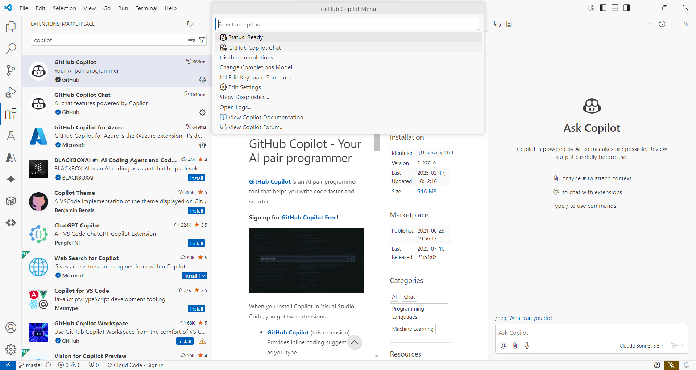

# Sample Prompts

1. **Code Generation**

Create a Python script that reads a CSV file and summarizes sales by region.

1. **UI Component**

Build a React component for a login form with email and password fields.

1. **Bug Fixing**

Fix the error in this JavaScript function that calculates total price.

1. **Documentation**

Write a README for a Node.js project that connects to MongoDB and exposes REST APIs.

1. **Refactoring**

Refactor this Java method to improve readability and reduce complexity.

**Prompt modes**

* **Write Mode** – for generating code
* **Chat Mode** – for understanding codebase
* **Legacy Mode** – for discussions

# References

## Cognizant – VS Code vendor collaboration

[Documentation for Visual Studio Code](https://code.visualstudio.com/docs)

# Change Log

|  |  |
| --- | --- |
| **Version Number** | **Changes Made** |
| V 1.0 | Initial baseline created on 72025 |
|  |  |
|  |  |